**Sales Performance Analysis Report**

**Introduction**

This report presents a detailed analysis of sales performance centered around critical parameters such as revenue, generation, employee contributions, product trends, and regional performance. The report highlights strong areas, identifies areas of improvement, and provides recommendations. Ultimately, this will assist the company in improving its sales, increasing employee productivity, and achieving growth on a built up and sustainable basis.

1. **Overall Sales and Revenue Analysis**
   1. **Total Revenue Generated**

During the period examined, the total revenue of $1,141,055.50 was recorded. The regional and category level performance indicates strong performance.

* 1. **Top 5 Revenue-Generating Regions**

The top 5 revenue generating regions are listed below with total revenue each:

* + 1. North: $310,284.25
    2. West: $304,749.60
    3. South: $269,520.00
    4. East: $256,501.65

The North region is a leader in revenue, with the share of revenues at approximately 27.2% of the total revenues.

* 1. **Region with Highest Average Revenue per Transaction**

The North region had the strongest average revenue per transaction, which denotes the ability and willingness to spend money on valuable goods.

* 1. **Correlation between discounts and sales**

The relationship between discount and sales is very weak, as the correlation coefficient is approximately 0.067.

1. **Employee Performance and Revenue**
   1. **Revenue**

This analysis of sales per employee reveals great differences in the productivity of single employees. Each employee’s impact is measured based on his or her sales which is then aggregated into total revenues to see how the business performs overall. For example, the top employee was able to produce $8,487 while the mean revenue between all employees comes to $2,282.11. This means that there is great variation in contribution levels.Allocating resources and planning employee training and development interventions will be influenced by the existing contribution differences.

* 1. **Top 3 Employees by Revenue Generated**

Melissa Haynes: $8,487.00

Andrew Booker: $8,387.55

Paul Hinton: $8,019.00

These employees together achieved a high proportion of the total revenue, as can be seen by their remarkable sales efforts.

* 1. **Average Employee Performance by Region**

The average performance scores for employees across regions are:

East: 4.92

North: 5.08

South: 5.11

West: 5.73

In the West region, the workers achieved the greatest average performance score, showing maximum interaction and sales to customers.

* 1. **Correlation Between Employee Performance Scores and Revenue Generated**

The analysis indicated the existence of weak positive correlation 0.0176 between employee performance scores and revenue achieved. This reveals that while higher performance scores do affect the revenue generated, other elements like product demand, pricing policy and geographical region perform a more crucial role.

1. **Product Performance**
   1. **Total Revenue and Units Sold for Each Product Category and Subcategory**

The report clearly shows a detailed breakdown of revenue and units sold by product out by category and subcategory:

**Electronics:**

* Washing Machines: $66,816.90, 146 units
* Laptops: $46,672.25, 101 units
* Smartphones: $33,596.40, 78 units
* Tables: $50,015.60, 99 units
* Sofas: $36,358.25, 98 units
* T-Shirts: $37,107.60, 106 units

**Furniture:**

* Laptops: $66,408.50, 132 units
* Sofas: $37,359.20, 80 units
* T-Shirts: $55,476.35, 101 units
* Tables: $48,888.15, 86 units
* Washing Machines: $53,626.00, 106 units

**Appliances:**

* Washing Machines: $55,995.90, 130 units
* T-Shirts: $53,570.20, 115 units
* Laptops: $53,430.50, 132 units
* Sofas: $34,423.70, 92 units
* Tables: $37,007.50, 64 units
* Smartphones: $31,342.90, 63 units

**Clothing:**

* Sofas: $54,682.70, 127 units
* Washing Machines: $44,390.65, 112 units
* Smartphones: $51,535.45, 111 units
* T-Shirts: $43,826.90, 100 units
* Tables: $51,325.30, 95 units
* Laptops: $37,421.85, 84 units
  1. **Top-Performing Product Subcategory Based on Revenue**

The category “s Electronics > Washing Machines” had the greater revenue with a total of $66,816.90. This had a great share of total sales as well, while 'Furniture > Laptops' came in second at $66,408.50.

* 1. **Average Discount Percentage by Product Category and Its Impact on Revenue**
     1. **Average Discount Percentage per Product Category:**
* Appliances: 13.02%
* Clothing: 12.10%
* Electronics: 12.91%
* Furniture: 13.09%
  + 1. **Total Revenue per Product Category:**
* Appliances: $265,770.70
* Clothing: $283,182.85
* Electronics: $270,567.00
* Furniture: $321,534.95
  + 1. **Correlation Between Discount Percentage and Revenue:**

This means that there is positive correlation, despite being very weak, between discount percentage and revenue. The discount percentage and revenue correlation coefficient is 0.176. These results imply that more discount sales may have some effect on sales but might not be major factors to revenue.

1. **Returns Analysis**
   1. **Return Rate by Region (Percentage of Transactions Returned)**

* South: 12.04% (highest return rate)
* West: 10.81%
* North: 8.20%
* East: 5.74% (lowest return rate)
  1. **Product Categories with the Highest Return Rates**
* Appliances: 10.34%
* Furniture: 9.92%
* Clothing: 8.73%
* Electronics: 7.87%
  1. **Correlation Between Discounts and Return Rates**

This weak correlation coefficient of -0.0265 suggests a weak negative relationship which indicates that higher discounts seem to have not much impact on return rates.

1. **Time-Series Analysis**

A time-series analysis of sales was conducted to examine how revenue fluctuated over the given period. The analysis revealed significant variations in daily revenue, with noticeable swings and specific dates exhibiting exceptionally high revenue.

The results of the analysis are as follows:

* Highest Sales Day: On September 19, 2024, the revenue peaked at $8,387.55, marking the most profitable day in the dataset.
* Lowest Sales Day: Conversely, the lowest revenue was recorded on December 23, 2023, with only $17.00 in sales.
* Average Daily Revenue: Over the entire period, the average daily revenue stood at $2,345.67, providing a benchmark for typical daily performance.

These insights highlight the variability in sales performance and can help identify trends, peak periods, and potential areas for improvement in revenue generation.

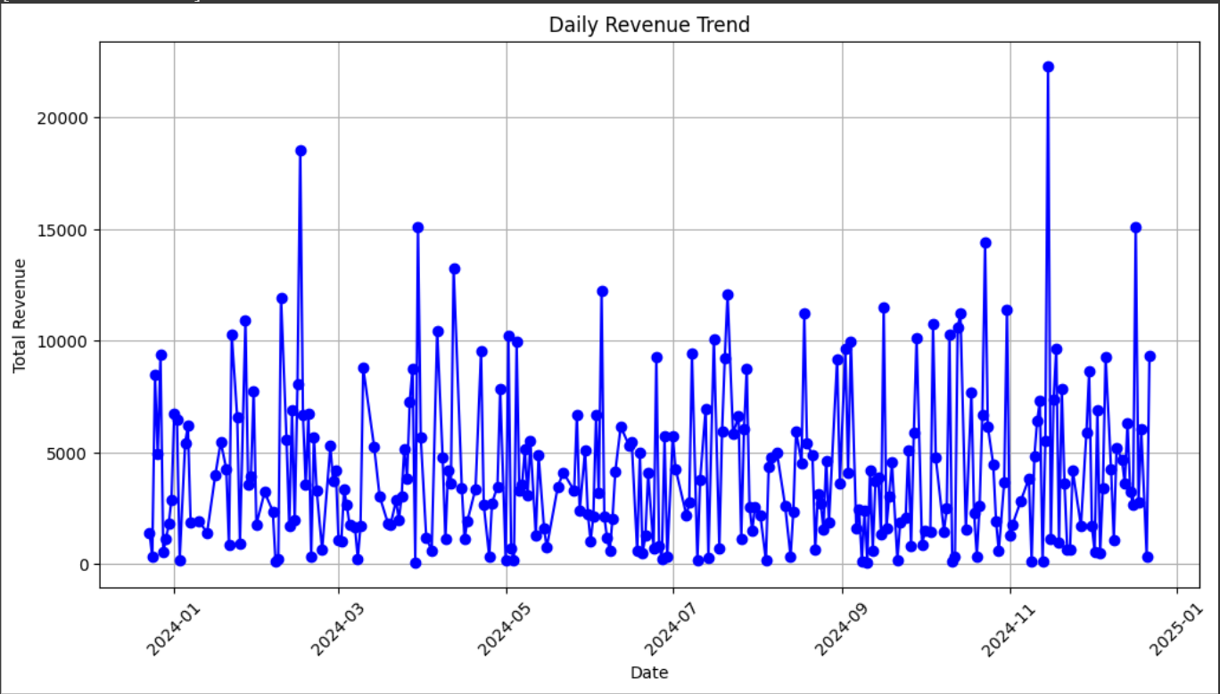

* 1. **Day of the Week with the Highest Revenue**

Total revenue per day during the week was calculated to determine the day with highest sales.

The analysis showed that Monday was the top performer among all days earning $192,481.15. This could point to more sales being done or more customers attending business activities at the start of the week.

Below are other day’s revenue earnings in the week:

* Tuesday: $155,231.50
* Wednesday: $149,249.90
* Thursday: $146,354.55
* Friday: $172,270.40
* Saturday: $167,563.95
* Sunday: $157,904.05
  1. **Seasonal Sales Patterns**

Sales reach their peak in Weeks 7, 13, 29, 43, 46, and 51. Sales from Weeks 43 to 52 are expected to increase from the original estimates due to the year end season. Sales are expected to have their greatest decrease during Weeks 10-15 and 31-35. In summary, sales follow a seasonal pattern fluctuation throughout the year.